Juan Pablo Balan Contreras

1126815

<https://github.com/JuanPabloBC7/Virtualizacion-Lab4/new/master?readme=1>

Pagina principal de instancias

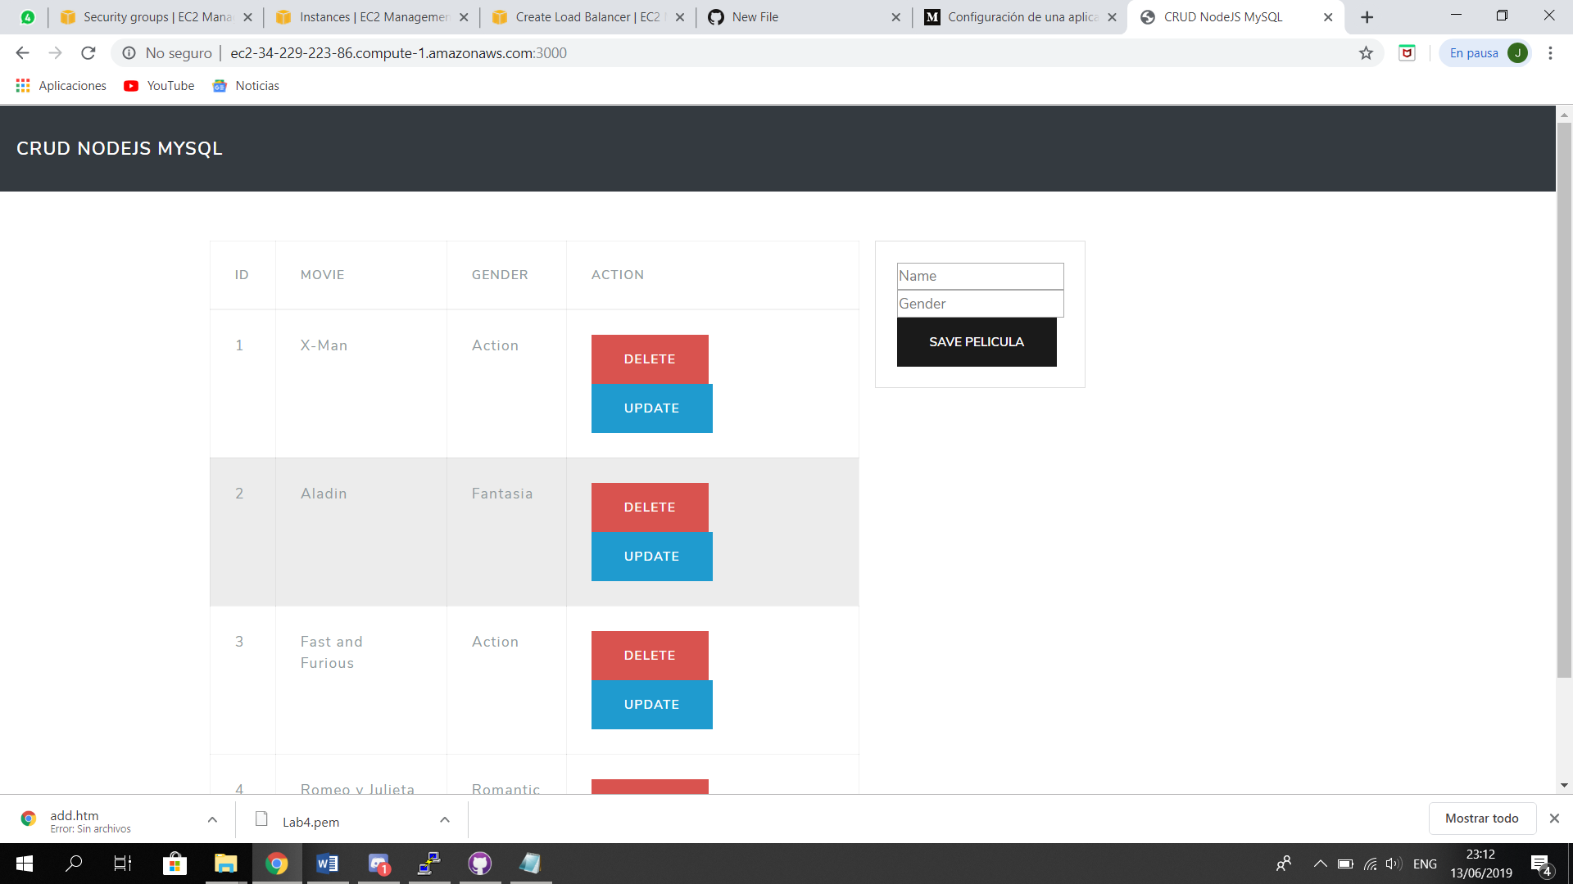

Security Group

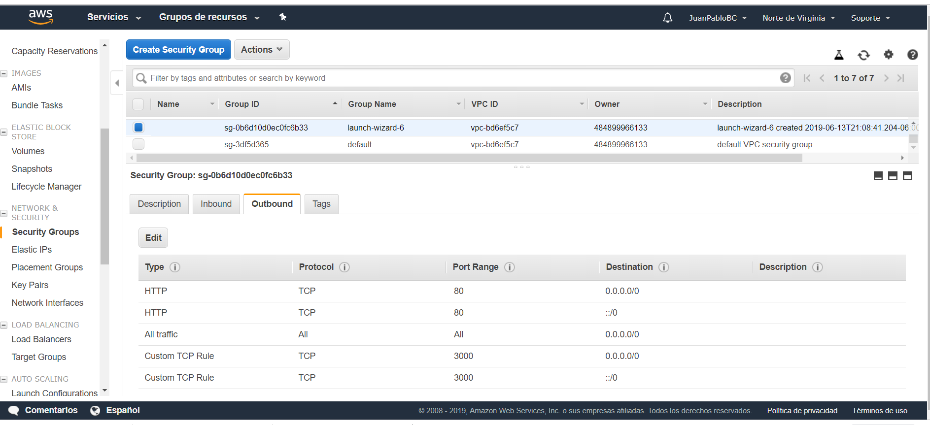

Instancias

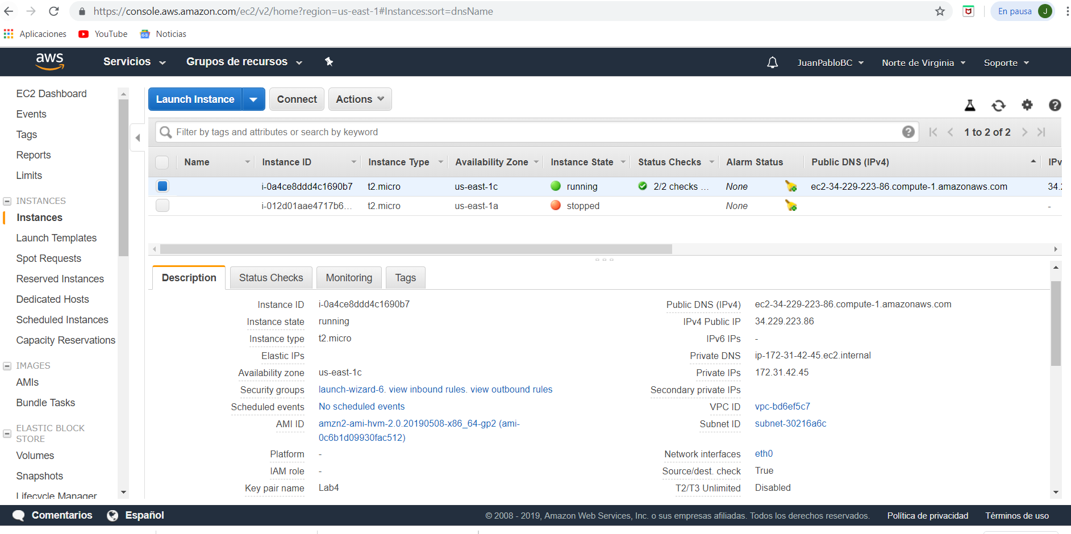

Load balancer Lab4

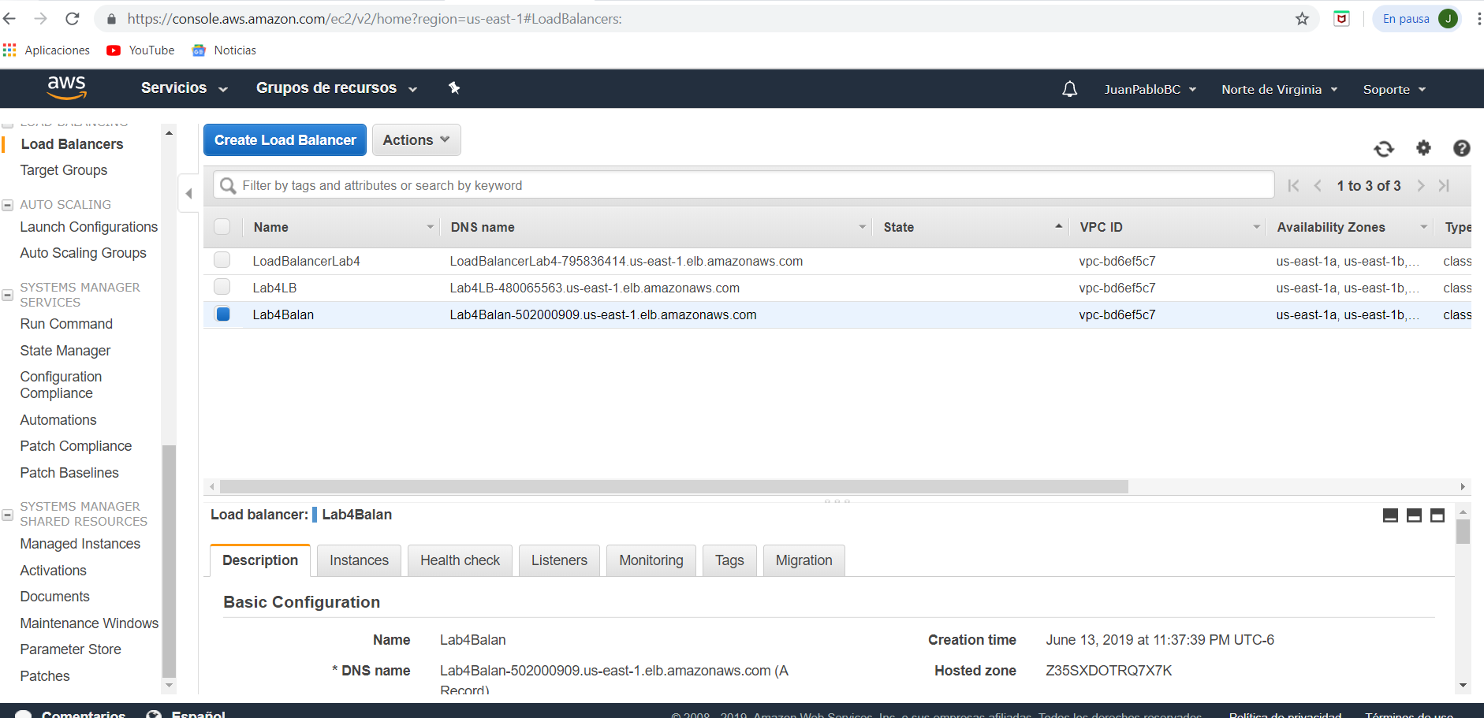

Security group

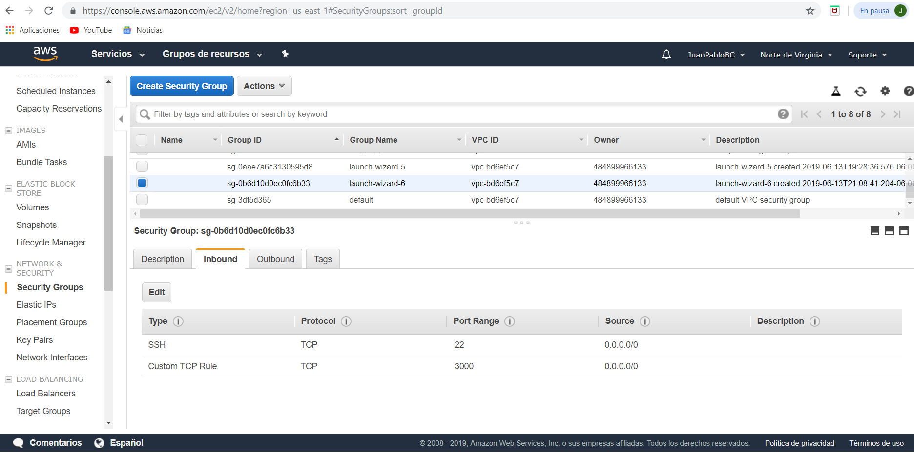

Link de la instancia

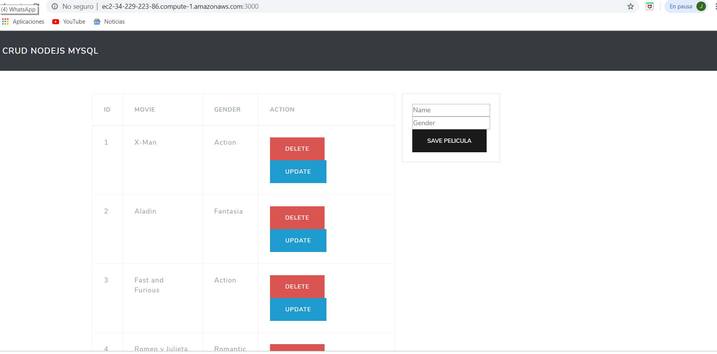

Link del load balancer

